Agate Analysis by Raman, XRF, and Hyperspectral Imaging Spectroscopy for Provenance Determination
Aaron J. Celestian
Arlen Heginbotham
Rebecca Greenberger
Bethany Ehlmann
Bibek Samanta
Alyssa Morgan
Sergey Mamedov
Bridget O’Donnell

Abstract
The Getty Museum recently acquired the Borghese-Windsor Cabinet (Figure ???), a piece of furniture extensively decorated with agate, lapis lazuli, and other semi-precious stones. The cabinet is thought to have been built around 1620 for Camillo Borghese (later Pope Paul V). The Sixtus Cabinet, built around 1585 for Pope Sixtus V (born Felice Peretti di Montalto), is of similar design to the Borghese-Windsor and also ornately decorated with gemstones. Although there are similarities in gemstones between the two cabinets, the Sixtus and Borghese-Windsor cabinets vary in their agate content. It was traditionally thought that all agate gemstones acquired during the 16th and 17th centuries were sourced from the Nahe River Valley near Idar-Oberstein, Germany. It is known that Brazilian agate began to be imported into Germany by the 1800s, but it is possible that some was imported in the 18th century or earlier. A primary research goal was to determine if the agates in the Borghese-Windsor Cabinet are of single origin, or if they have more than one geologic provenance.
Agates are made of SiO₂, mostly as the mineral quartz, but also as metastable moganite. Both quartz and moganite will crystallize together as the agate forms, but moganite is not stable at Earth’s surface and will convert to quartz over tens of millions of years (Moxon and Ríos 2004; Heaney 1995; Gíslason et al. 1997), thus relatively older agate contains less moganite. Agate from the Idar-Oberstein is Permian in age (around 280 million years old), while agate from Rio Grande do Sul of Brazil generally formed during the Cretaceous (around 120 million years old). It is thought that Rio Grande do Sul would have been a primary source of material exported to Europe because it is one of Brazil’s oldest and largest agate gemstone producers. Since Cretaceous agate from Brazil is many millions of years younger than Permian agate from Germany, the quartz to moganite ratios between the two localities should be quite different.
The agate gemstones of the Borghese-Windsor Cabinet cannot be removed for detailed Raman mapping experiments. Because of this, we first analyzed multiple agate specimens from the collections of the Natural History Museum of Los Angeles (NHMLA) and the Smithsonian Institution National Museum of Natural History (NMNH) using three different techniques: Raman mapping, XRF mapping, and hyperspectral imaging. Raman spectroscopy provides an easy method to distinguish the relative quartz:moganite ratios and XRF analysis provides a measure of bulk geochemistry in agates. Maps have advantages over line scans and point analysis in that they give a better representation of the mineral content, can be used to exclude trace mineral impurities, and yield better counting statistics and averaging. Hyperspectral imaging provides a range of optical data from IR through UV wavelengths.
We performed Raman mapping (Horiba ExploRa+ 532 nm and 785 nm lasers) and XRF mapping (Horiba XGT-7200) at NHMLA on agates of known provenance that could later be compared to gemstones in the Borghese-Windsor Cabinet. When examining the cryptocrystalline parts of agate from comparative collections, Brazilian agates (e.g. Figure ??? from NHMLA collection) had 8% or higher moganite concentration, whereas the Idar-Oberstein agate (on loan from NMNH) had less than 2% moganite. No intermediate moganite percentages were observed for the specimens that were examined. Well-crystallized areas and microcrystalline areas within the same agate had little to no moganite. The moganite distribution in the agate is heterogeneous (e.g. Figure ???), likely due to different growth stages and changing geological conditions during agate formation. Using the Raman maps, we were able to isolate the areas that contained moganite + quartz, and measure the ratios in those specific bands (e.g. Figure ???). This narrow-band approach to quartz:moganite determination was compared to broad-brand and whole-sample approaches, and the narrow-band approach was shown to be more reproducible in distinguishing Brazilian from German agates. Because moganite is isolated to select layers/bands within agate, care must be taken when evaluating quartz:moganite ratios for provenance or age analysis.
These same agates from the Brazilian and German localities were then taken to CalTech to collect hyperspectral imaging data. Imaging data were compared to the NHMLA laboratory Raman and XRF analyses, and correlation analysis of combined datasets from the three different experimental procedures allowed us to establish a unique characterization pattern for the different localities. At the Getty Museum, we performed hyperspectral imaging of the entire cabinet (Figure ???), and analyzed select drawers from the cabinet via large volume XRF. These analyses will then be compared to the data collected from known localities to attempt to determine provenance of the Borghese-Windsor agates. The procedure can be used to establish datasets for the other locations in the future.

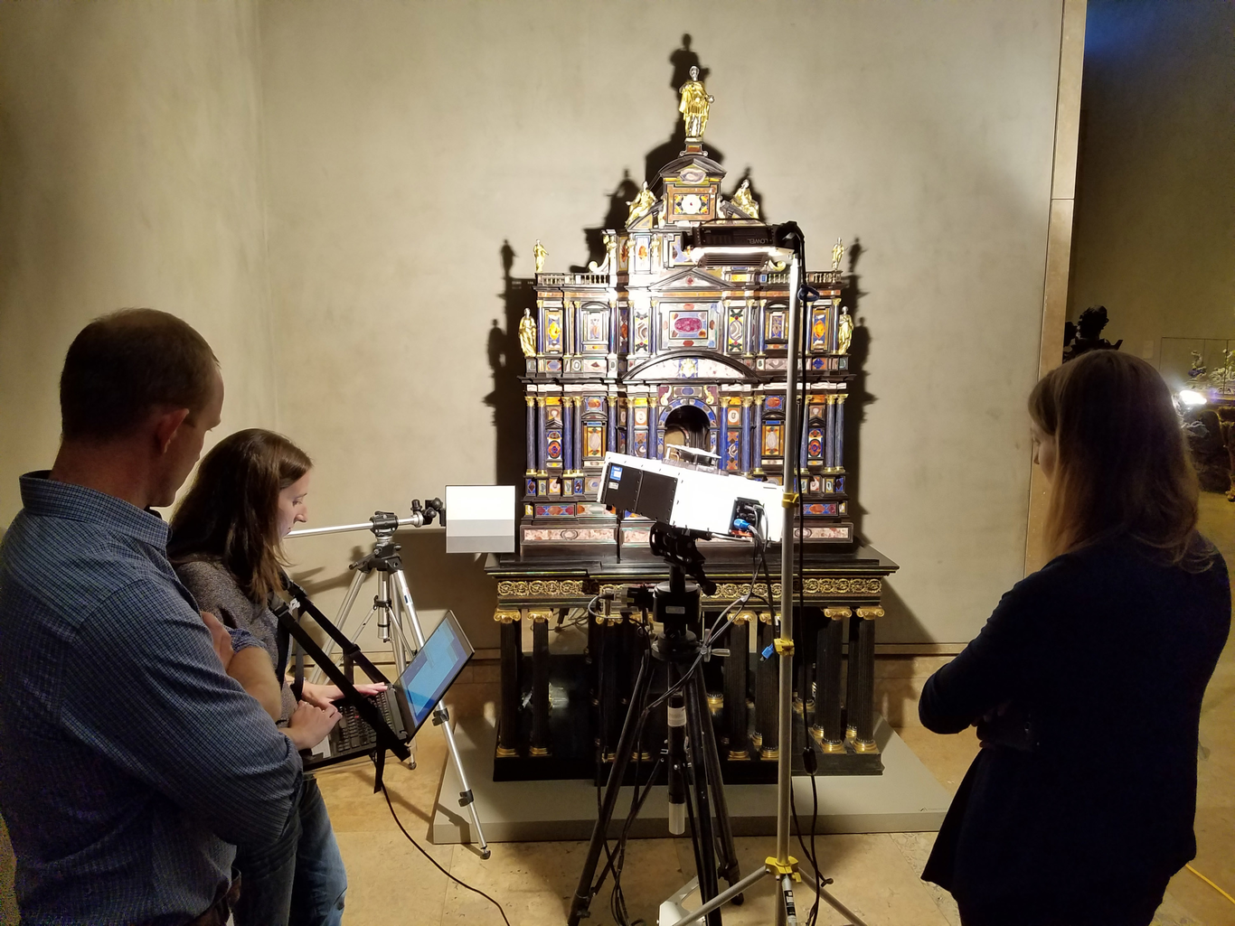
Getty Borghese-Windsor Cabinet on display at the Getty Center, and being imaged by the hyperspectral analyzer (center, on tripod). From left to right: A. Celestian, R. Greenberger, B. Elm.
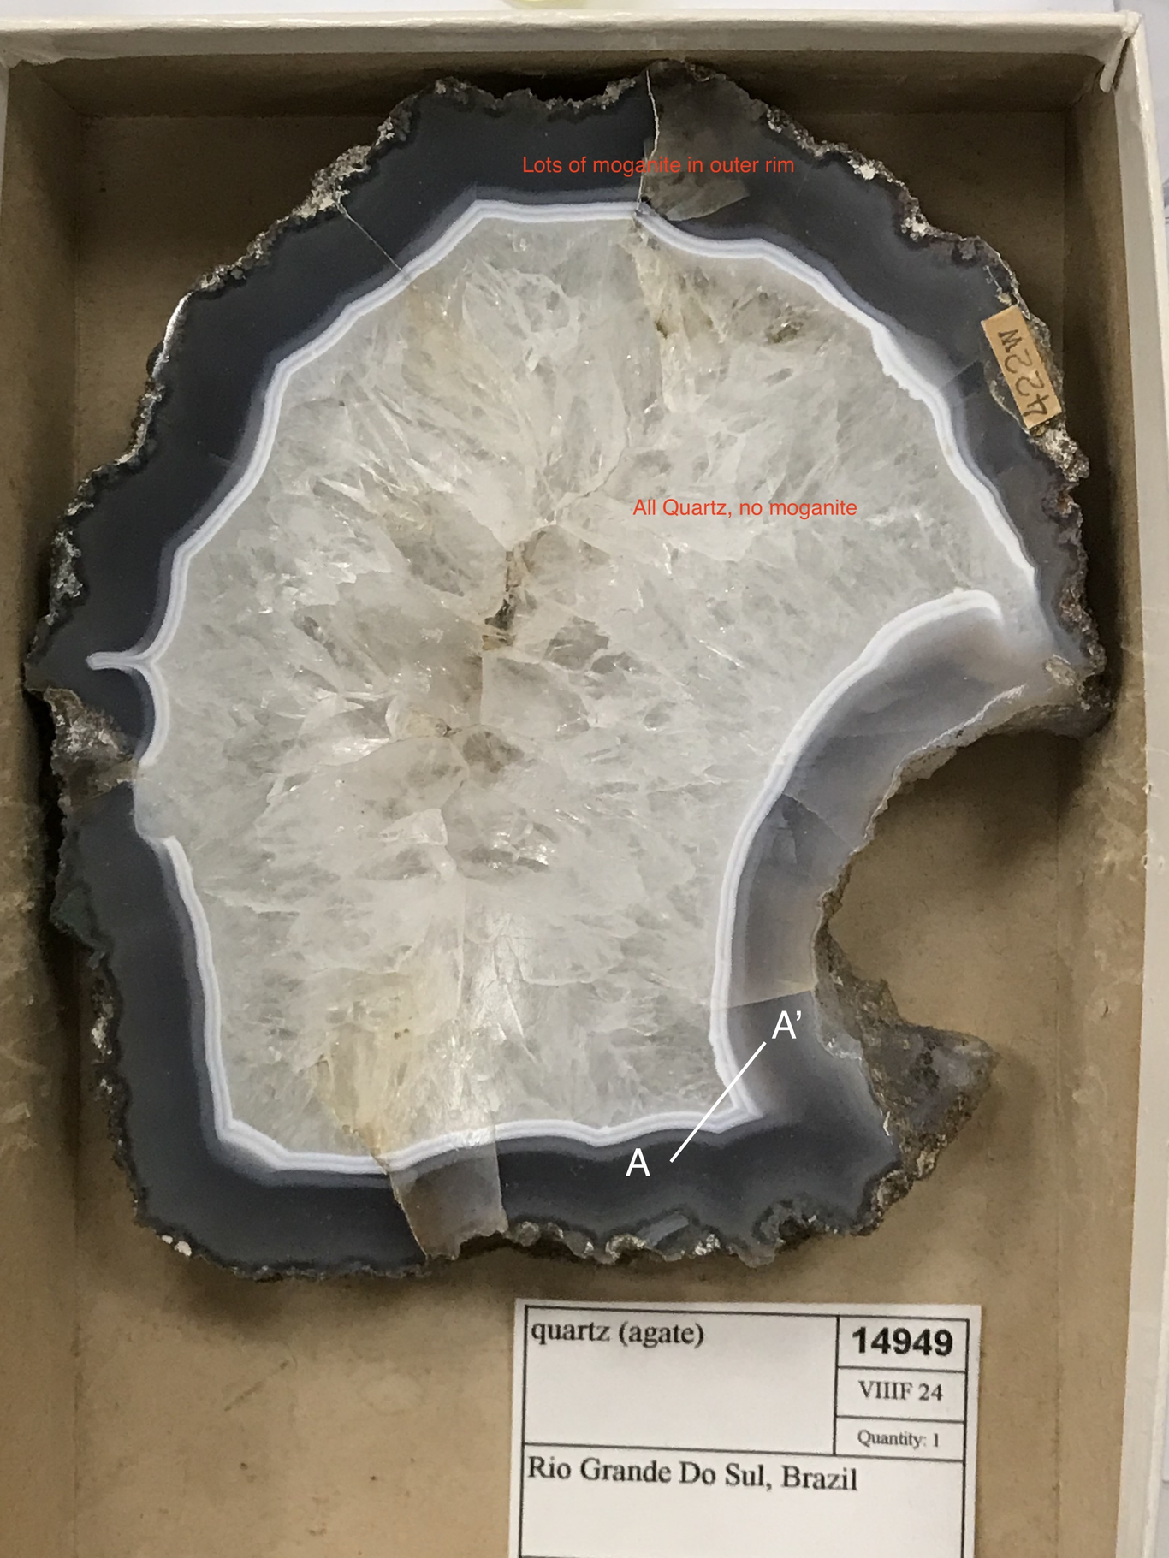
Brazilian agate from Rio Grande Do Sul from the NHMLA collection. Transect A-A’ is where Raman map was collected.
Raman map showing high quartz as bright areas, and quartz+moganite as dark areas along the A-A’ transect show in Figure ???. The brighter bands contain no less than 8% moganite while the dark bands contain only quartz. This narrow-band analysis yield better provenance results than from whole-rock, or broad-band analysis.
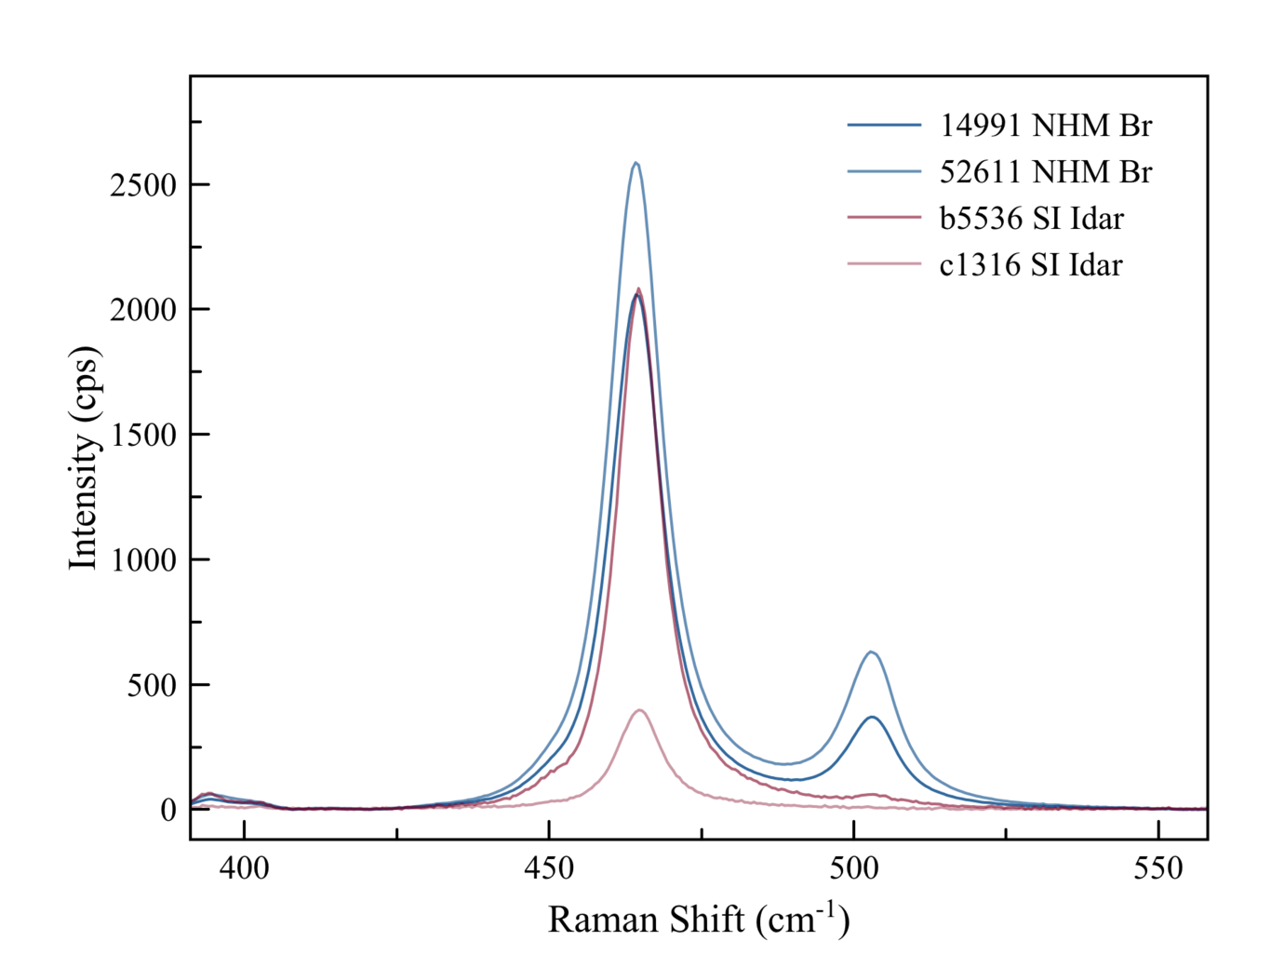
Example data comparing four different agate Raman analyses in the diagnostic region between 400 cm⁻¹ to 550 cm⁻¹ region showing the strongest peaks for quartz at 463 cm⁻¹ and moganite at 501 cm⁻¹. These data were taken from narrow-band analysis (summing all spectra in the narrow agate bands that contained quartz + moganite). Each band was used as a separate analysis. Shown are the analyses of two different agates from Brazil (blues), and two different agates from from Germany (reds). Note the strong moganite presence in the Brazilian agates.

References
Moxon, Terry, and Susana Ríos. 2004. “Moganite and Water Content as a Function of Age in Agate: an XRD and Thermogravimetric Study”. European Journal of Mineralogy 16 (2): 269–78. https://doi.org/10.1127/0935-1221/2004/0016-0269.
Heaney, Peter J. 1995. “Moganite as an Indicator for Vanished Evaporites: A Testament Reborn?”. SEPM Journal of Sedimentary Research Vol. 65A. https://doi.org/10.1306/d4268180-2b26-11d7-8648000102c1865d.
Gíslason, Sigurdur R., Peter J. Heaney, Eric H. Oelkers, and Jacques Schott. 1997. “Kinetic and Thermodynamic Properties of Moganite a Novel Silica Polymorph”. Geochimica Et Cosmochimica Acta 61 (6): 1193–1204. https://doi.org/10.1016/s0016-7037(96)00409-7.

